Questions and Exercises to work out and turn in:

Grading Guidelines:

* A right answer will get full credit when:

1. It is right (worth 25%)
2. It is right **AND** neatly presented making it easy and pleasant to read. (worth an **extra** 15%)
3. There is an **obvious and clear link** between 1) the information provided in the exercise and in class and 2) the final answer. A clear link is built by properly writing, justifying, and documenting an answer (worth an **extra** 60%).
4. Calculation mistakes will be minimally penalized (2 to 5% of full credit) while errors on units will be more heavily penalized.

You are welcome/encouraged to discuss exercises with other students or the instructor. But, ultimately, **personal** writing is expected.

* USE THIS FILE AS THE STARTING DOCUMENT YOU WILL TURN IN. **DO NOT DELETE ANYTHING FROM THIS FILE:** JUST **INSERT** EACH ANSWER **RIGHT AFTER ITS QUESTION/PROMPT**.
* IF USING HAND WRITING (STRONGLY DISCOURAGED), **USE THIS FILE** BY CREATING SUFFICIENT SPACE AND WRITE IN YOUR ANSWERS.

FAILING TO FOLLOW TURN IN DIRECTIONS /GUIDELINES WILL COST **A 30% PENALTY.**

Objectives of this assignment:

* to use and manipulate the concepts presented in this module
* to propose and write algorithms in pseudocode
* to analyze the time complexity of algorithms
* to analyze the space complexity of algorithms
* to learn autonomously new concepts

What you need to do:

Answer the questions and/or solve the exercises described below.

Exercise 1 (50 points)

Run the Bellman-Ford algorithm on the directed graph of Figure 1.1, using vertex as the source. In **each pass**, relax edges in the order provided on Figure 1.2, and using the **style/format** of Figure 24.4 (Textbook). A pass is the execution of the *For Loop* Lines 3-4 (Bellman-Ford algorithm). Show the ***d*** and values after **each pass** (over all edges on Figure 1.2)

It is ok to draw by hand the graphs, take picture(s), and insert as long as it is neat (neatness is worth 15%). A pass means that you relax through the list of all edges on Figure 1.2.

Justify in detail the first **two** passes **only** (recall the direct link....**60%**). You must show your results after each pass, but you justify in detail only for the first two passes.

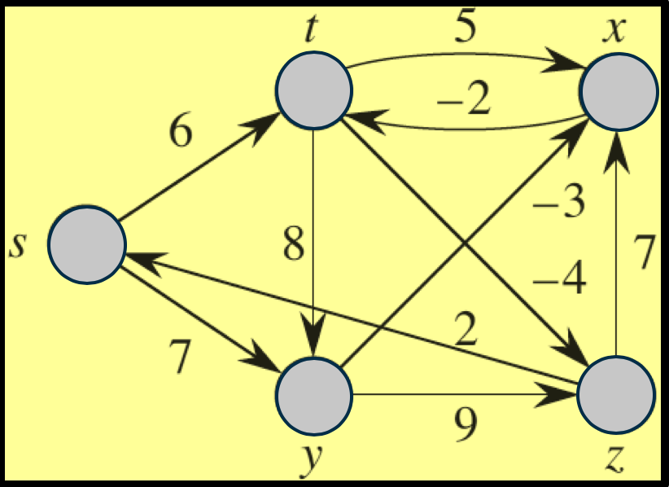 **(t, y), (s, t), (z, s), (y, x), (s, y), (z, x), (t, x), (t, z), (x, t), (y, z)**

Figure 1.1 Graph Figure 1.2 Edges Order

Before First Iteration After First Iteration

After Second Iteration After Third Iteration  
**

After Fourth Iteration  
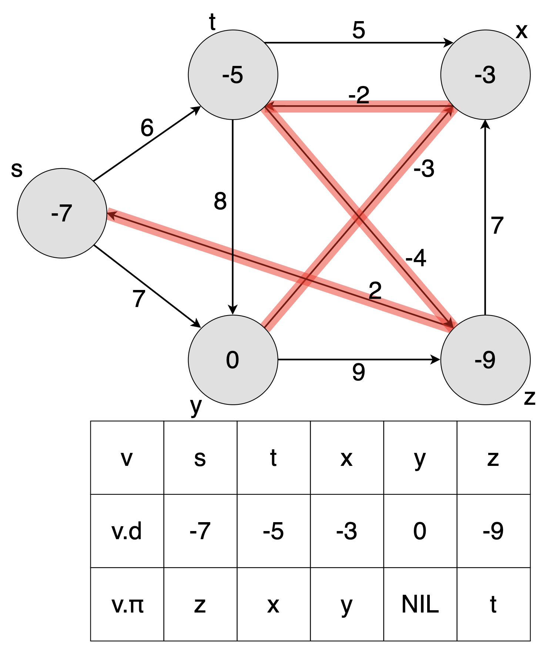

**Exercise 2 (50 points)** (**Note**: This exercise uses a different graph than Exercise 1)

Run Dijkstra’s algorithm on the directed graph G = (V, E) of Figure 2.1 using vertex as the source (using a different source will result in no credit awarded). **In the style of Figure 24.6 (Textbook)**, show the and values and the vertices in set S **after each iteration** of the while loop. We expect the vertices to be highlighted the same way as on Figure 24.6.

It is ok to draw by hand the graphs, take picture(s), and insert as long as it is neat (neatness is worth 15%).

**Justify in detail** the first **two** passes **only** (recall the direct link....60%). You must show your results after each pass, but you justify in detail only for the first two passes.

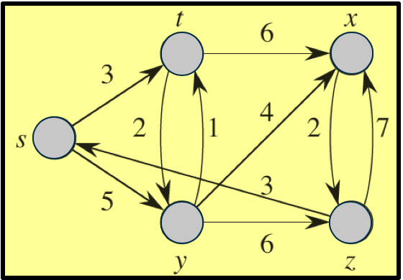

Figure 2 Graph G

Before First Iteration After First Iteration

After Second Iteration After Third Iteration

After Fourth Iteration After Fifth Iteration

What you need to turn in:

* Electronic copy of this file (including your answers) (standalone). Submit the file as a Microsoft Word or PDF file.
* Recall that answers must be well written, documented, justified, and presented to get full credit.
* How this assignment will be graded:
* A right answer will get full credit when:
* It is right (worth 25%)
* It is right AND neatly presented making it easy and pleasant to read. (worth 15%)
* There is an obvious and clear link between 1) the information provided in the exercise and in class and 2) the final answer. A clear link is built by properly writing, justifying, and documenting an answer (worth 60%).
* Calculation mistakes will be minimally penalized (2 to 5% of full credit) while errors on units will be more heavily penalized.
* You are welcome/encouraged to discuss exercises with other students or the instructor. But, ultimately, personal writing is expected.

See appendix below for details about grading.

**Appendix**: Grading: What is an OBVIOUS and CLEAR LINK?

Here is an example to explain what an **obvious and clear link** is and how we grade your work.

Consider the following problem:

"(100 points) John travels from Auburn to Atlanta in his car at a speed of 60 mph. Leaving at 8am, at what time will John reach Atlanta".

Here are the answers of three students and their scores:

* **Student 1** answers: "9:48am". Student 1 will get 25 points.
* **Student 2**answers : "John will reach Atlanta at 9:48am". Student 2 will get 25+15 = 40 points
* **Student 3** answers: "The time t to travel a distance d at speed v is equal to d/v = d/60mph. The problem does not provide the distance d from Auburn to Atlanta. Based on GoogleMaps, the distance from Auburn to Atlanta is approximately 108 miles (**document is attached**).

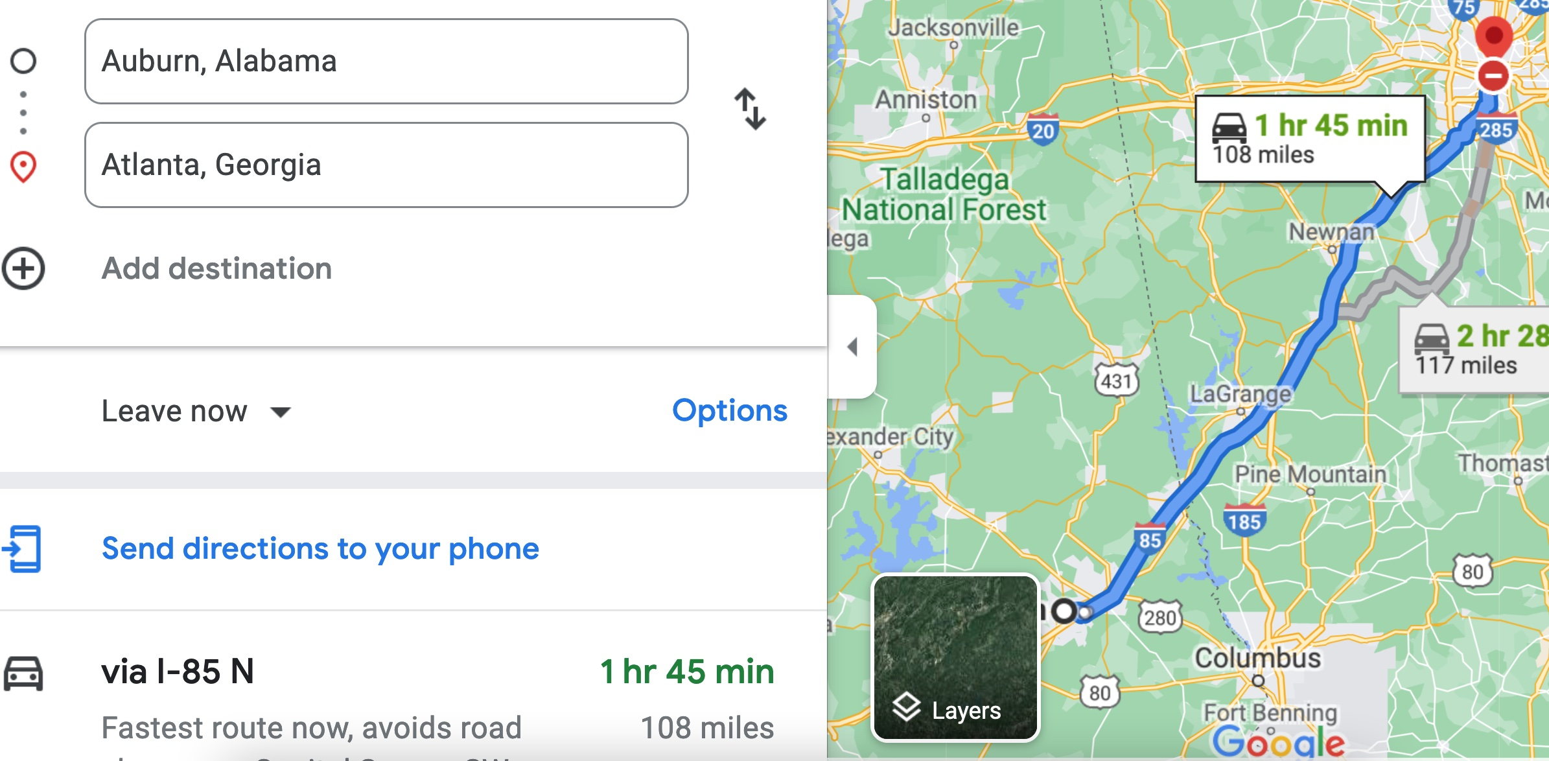

Therefore, the time t = 108 miles/60mph * 60 minutes/hour= 108 minutes. Since John left at 8am, he will then reach Atlanta at 8am + 108 minutes = 8 am + 60 minutes + 48 minutes = 9:48".

**Student 3** will get 25 + 15 + 60 = 100 points

Do you see the **direct** **link** going from the data provided in the question to the final answer, using general knowledge/formula and documents?.... Can you now solve the following problem and get 100 points?

"(100 points) Alice travels from Auburn to Atlanta in her car at a speed of 60 mph. Leaving at 8am, at what time will Alice reach Atlanta assuming that she had a flat tire that delayed her 30 minutes".